Q1.
Answer is B.

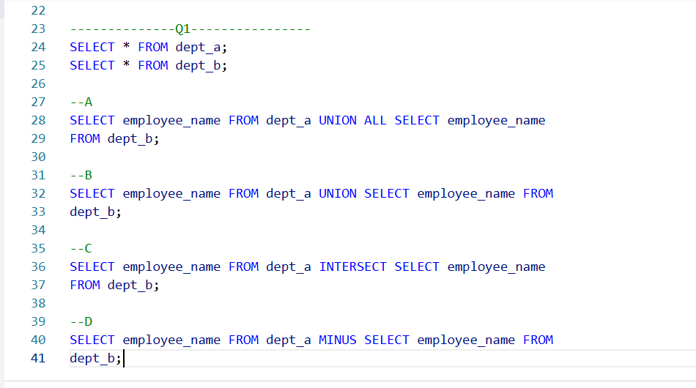

A: Incorrect. UNION ALL combines all rows from both queries and keep duplicates.

B: Correct. UNION combines all rows from both tables and remove duplicates.

C: Incorrect. INTERSECT returns only the rows that exist in BOTH tables.

D: Incorrect. MINUS returns data that are in TableA but not in TableB.

Q2.
Answer is

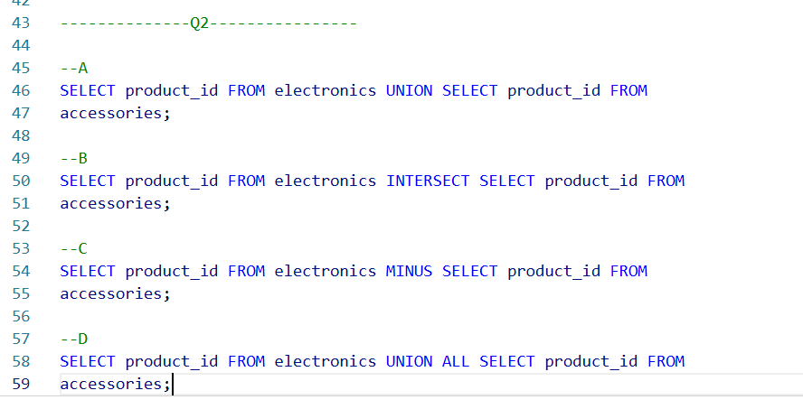

A: Incorrect. UNION combines all rows from both tables and remove duplicates.

B: Correct. INTERSECT returns only the rows that exist in BOTH tables.

C: Incorrect. MINUS returns data that are in TableA but not in TableB.

D: Incorrect. UNION ALL combines all rows from both queries and keep duplicates.

Q3.
Answer is C.

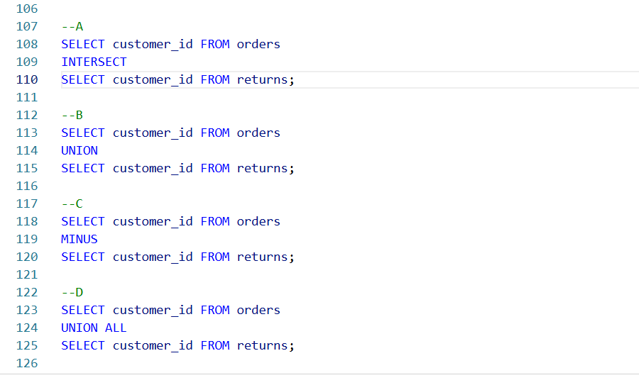

A: Incorrect. INTERSECT returns only the rows that exist in BOTH tables.

B: Incorrect. UNION combines all rows from both tables and remove duplicates.

C: Correct. MINUS returns data that are in TableA but not in TableB.

D: Incorrect. UNION ALL combines all rows from both queries and keep duplicates.

Q4.
Answer is C.

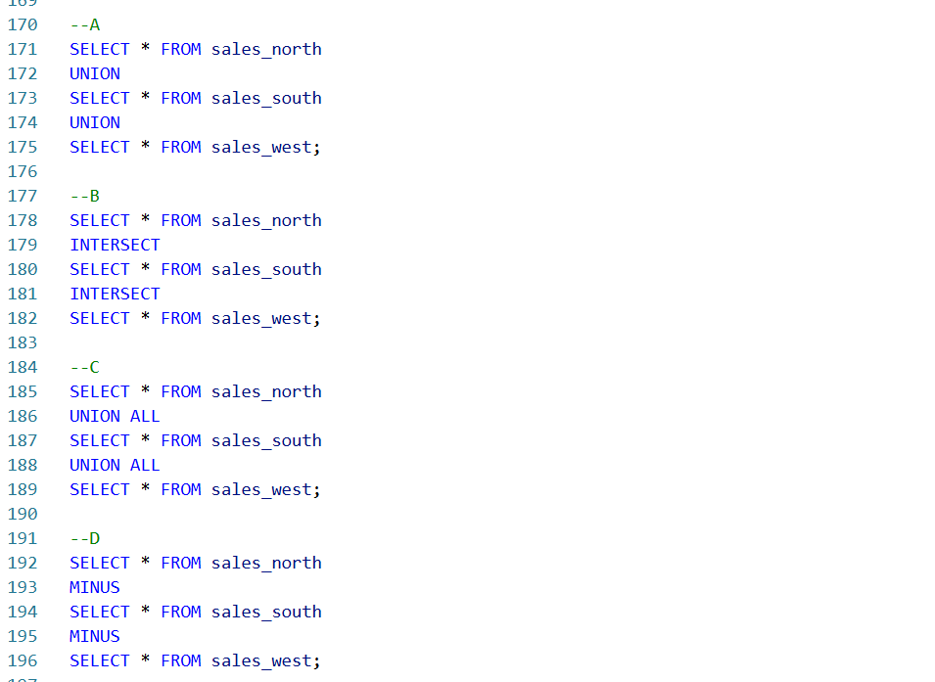

A: Incorrect. UNION combines all rows from both tables and remove duplicates.

B: Incorrect. INTERSECT returns only the rows that exist in BOTH tables.

C: Correct. UNION ALL combines all rows from both queries and keep duplicates.

D: Incorrect. MINUS returns data that are in TableA but not in TableB.

Q5.
Answer is C.

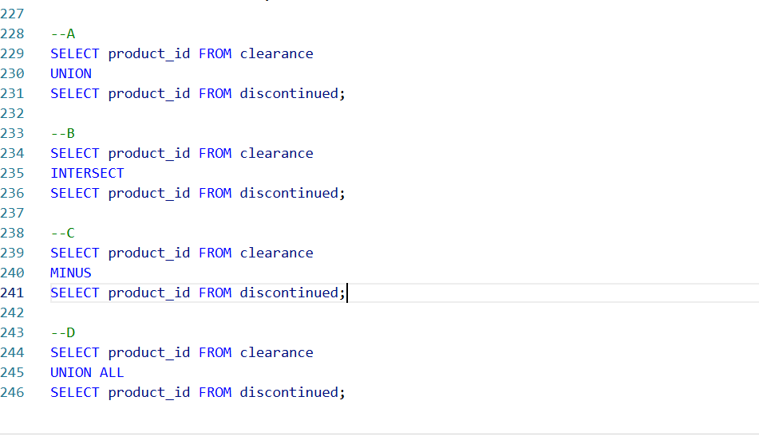

A: Incorrect. UNION combines all rows from both tables and remove duplicates.

B: Incorrect. INTERSECT returns only the rows that exist in BOTH tables.

C: Correct. MINUS returns data that are in TableA but not in TableB.

D: Incorrect. UNION ALL combines all rows from both queries and keep duplicates.

Q6.
Answer is C.

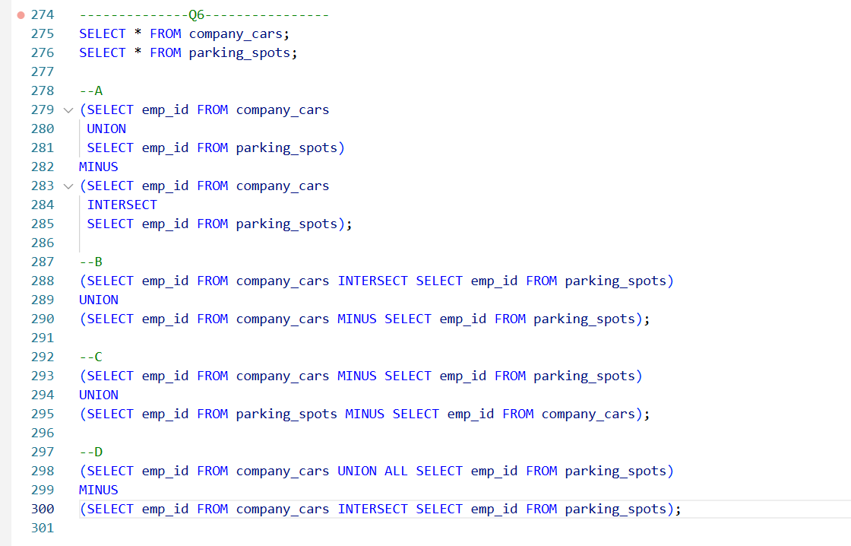

A: Correct. works but more complex than C.

B: Incorrect. Includes employees with both car & parking, which should be excluded

C: Correct. XOR either car or parking, but not both.

D: Incorrect. Works but UNION ALL may cause duplicates.

Q7.
Answer is B.

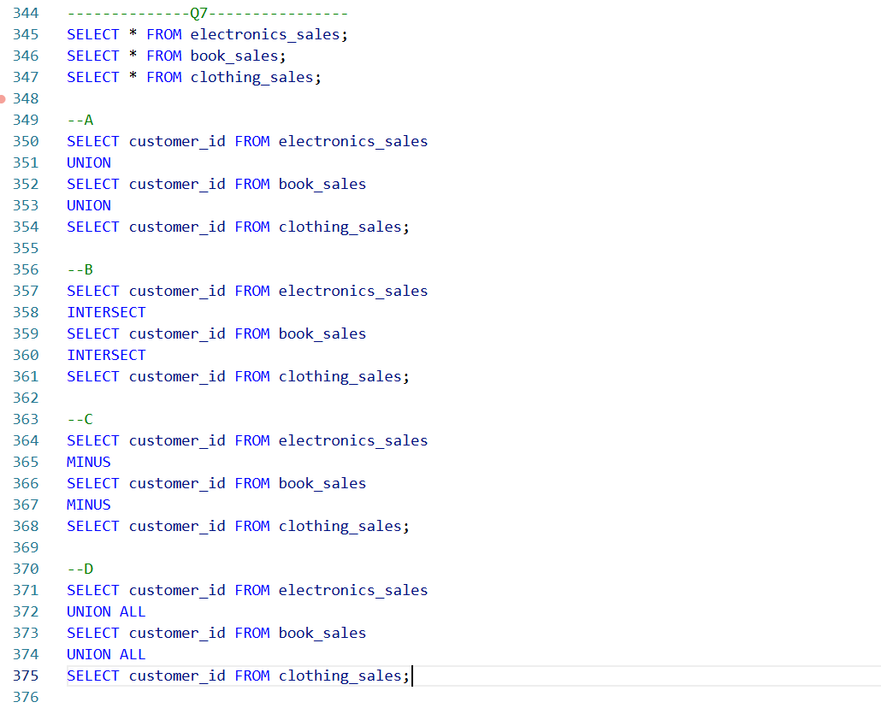

A: Incorrect. Combines all unique customer_ids from the three tables.

B: Correct. Returns only customers present in all three tables.

C: Incorrect. Result will not include the correct set of customers.

D: Incorrect. UNION ALL combines all rows from both queries and keep duplicates.

Q8.
Answer is

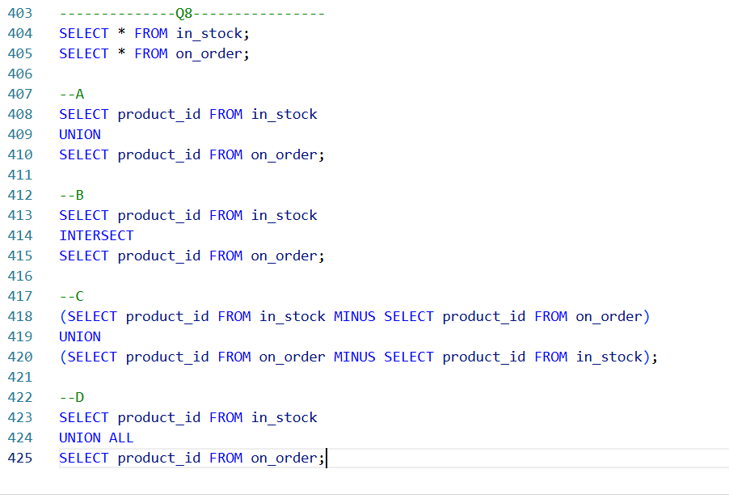

A: Incorrect. UNION combines all rows from both tables and remove duplicates.

B: Incorrect. INTERSECT returns only the rows that exist in BOTH tables.

C: Correct. XOR either car or parking, but not both.

D: Incorrect. UNION ALL combines all rows from both queries and keep duplicates.

